Simulation-Based Frequency-Domain Characterization of a Microwave Two-Port Network Using S-Parameters and Network-Analyzer Emulation
Aim:
To simulate and characterize a microwave two-port network in the frequency domain using S-parameters and emulate a vector network analyzer (VNA) to evaluate its reflection and transmission characteristics.
Procedure:
- Open MATLAB or suitable microwave simulation software.
- Define the two-port network parameters, operating frequency range, characteristic impedance, and network configuration.
- Calculate or simulate the S-parameters: \(S_{11}\), \(S_{21}\), \(S_{12}\), and \(S_{22}\).
- Emulate a vector network analyzer by sweeping the frequency and displaying the magnitude and phase of the S-parameters.
- Plot the S-parameters against frequency and analyze return loss, insertion loss, transmission, and impedance matching.
- Evaluate the network performance and compare the simulated results with the expected theoretical characteristics.
Code:
clc;
clear;
close all;
%% 1. INPUT PARAMETERS
fstart = 8e9; % Start frequency = 8 GHz
fstop = 12e9; % Stop frequency = 12 GHz
Z0 = 50; % Reference impedance = 50 ohms
df = 0.01e9; % Frequency step = 0.01 GHz
% Frequency vector
f = (fstart:df:fstop).';
N = length(f);
%% 2. TWO-PORT NETWORK MODEL
% Example DUT: matched 50-ohm transmission line
% with frequency-dependent attenuation and phase.
% These parameters are illustrative and can be changed.
Zc = 50; % Characteristic impedance (ohms)
lineLength = 0.03; % Transmission line length (m)
c = 3e8; % Speed of light (m/s)
vf = 0.7; % Assumed velocity factor
alpha_dB_per_m = 10; % Assumed attenuation (dB/m)
% Allocate S-parameter arrays
S11 = zeros(N,1);
S21 = zeros(N,1);
S12 = zeros(N,1);
S22 = zeros(N,1);
for k = 1:N
freq = f(k);
% Propagation constant
alpha = alpha_dB_per_m/8.686; % Np/m
beta = 2*pi*freq/(vf*c);
gamma = alpha + 1j*beta;
% Transmission-line ABCD parameters
A = cosh(gamma*lineLength);
B = Zc*sinh(gamma*lineLength);
C = sinh(gamma*lineLength)/Zc;
D = cosh(gamma*lineLength);
% Convert ABCD parameters to S-parameters
denominator = A + B/Z0 + C*Z0 + D;
S11(k) = (A + B/Z0 - C*Z0 - D)/denominator;
S21(k) = 2/denominator;
S12(k) = 2*(A*D-B*C)/denominator;
S22(k) = (-A + B/Z0 - C*Z0 + D)/denominator;
end
%% 3. MAGNITUDE IN dB AND PHASE
S11_dB = 20*log10(max(abs(S11),1e-12));
S21_dB = 20*log10(max(abs(S21),1e-12));
S12_dB = 20*log10(max(abs(S12),1e-12));
S22_dB = 20*log10(max(abs(S22),1e-12));
S11_phase = unwrap(angle(S11))*180/pi;
S21_phase = unwrap(angle(S21))*180/pi;
S12_phase = unwrap(angle(S12))*180/pi;
S22_phase = unwrap(angle(S22))*180/pi;
%% 4. DISPLAY SUMMARY
fprintf('MICROWAVE TWO-PORT NETWORK ANALYSIS\n');
fprintf('-----------------------------------\n');
fprintf('Start frequency : %.2f GHz\n',fstart/1e9);
fprintf('Stop frequency : %.2f GHz\n',fstop/1e9);
fprintf('Reference impedance : %.2f ohms\n',Z0);
fprintf('Frequency step : %.3f GHz\n',df/1e9);
fprintf('Number of points : %d\n',N);
fprintf('DUT type : Transmission line\n');
fprintf('Line length : %.2f mm\n',lineLength*1e3);
% Find the data point closest to 10 GHz
[~,idx10] = min(abs(f-10e9));
fprintf('\nS-PARAMETERS AT %.2f GHz\n',f(idx10)/1e9);
fprintf('S11 = %.4f %+.4fj\n',real(S11(idx10)),imag(S11(idx10)));
fprintf('S21 = %.4f %+.4fj\n',real(S21(idx10)),imag(S21(idx10)));
fprintf('S12 = %.4f %+.4fj\n',real(S12(idx10)),imag(S12(idx10)));
fprintf('S22 = %.4f %+.4fj\n',real(S22(idx10)),imag(S22(idx10)));
fprintf('\nS11 magnitude = %.2f dB\n',S11_dB(idx10));
fprintf('S21 magnitude = %.2f dB\n',S21_dB(idx10));
fprintf('S12 magnitude = %.2f dB\n',S12_dB(idx10));
fprintf('S22 magnitude = %.2f dB\n',S22_dB(idx10));
fprintf('\nReturn loss at 10 GHz = %.2f dB\n',-S11_dB(idx10));
fprintf('Insertion loss at 10 GHz = %.2f dB\n',-S21_dB(idx10));
%% 5. PLOT S-PARAMETER MAGNITUDES
figure;
plot(f/1e9,S11_dB,'LineWidth',1.8);
hold on;
plot(f/1e9,S21_dB,'LineWidth',1.8);
plot(f/1e9,S12_dB,'LineWidth',1.8);
plot(f/1e9,S22_dB,'LineWidth',1.8);
grid on;
xlabel('Frequency (GHz)');
ylabel('Magnitude (dB)');
title('Two-Port Network S-Parameter Magnitudes');
legend('S11','S21','S12','S22','Location','best');
%% 6. PLOT RETURN LOSS
figure;
plot(f/1e9,-S11_dB,'b','LineWidth',1.8);
hold on;
plot(f/1e9,-S22_dB,'r--','LineWidth',1.8);
grid on;
xlabel('Frequency (GHz)');
ylabel('Return Loss (dB)');
title('Input and Output Return Loss');
legend('Input Return Loss','Output Return Loss','Location','best');
%% 7. PLOT INSERTION LOSS
figure;
plot(f/1e9,-S21_dB,'m','LineWidth',1.8);
grid on;
xlabel('Frequency (GHz)');
ylabel('Insertion Loss (dB)');
title('Forward Transmission Insertion Loss');
%% 8. PLOT PHASE RESPONSE
figure;
plot(f/1e9,S11_phase,'LineWidth',1.5);
hold on;
plot(f/1e9,S21_phase,'LineWidth',1.5);
plot(f/1e9,S12_phase,'LineWidth',1.5);
plot(f/1e9,S22_phase,'LineWidth',1.5);
grid on;
xlabel('Frequency (GHz)');
ylabel('Phase (degrees)');
title('Two-Port Network Phase Response');
legend('Phase S11','Phase S21','Phase S12','Phase S22', ...
'Location','best');
%% 9. SMITH CHART
figure;
smithplot(S11);
title('Input Reflection Coefficient on Smith Chart');
%% 10. TRANSMISSION CHECK
% For a passive network, transmitted plus reflected
% power should not exceed incident power.
powerSum = abs(S11).^2 + abs(S21).^2;
figure;
plot(f/1e9,powerSum,'k','LineWidth',1.8);
grid on;
xlabel('Frequency (GHz)');
ylabel('|S11|^2 + |S21|^2');
title('Input Power Balance Check');
yline(1,'r--','Unity');
fprintf('\nSimulation completed successfully.\n');

Output:
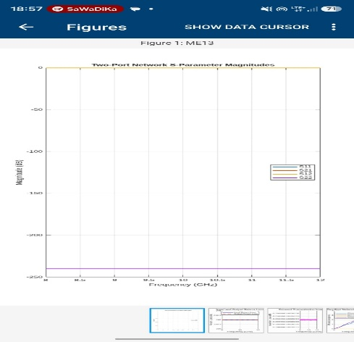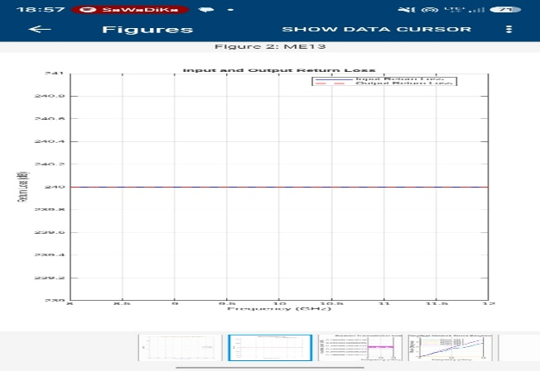
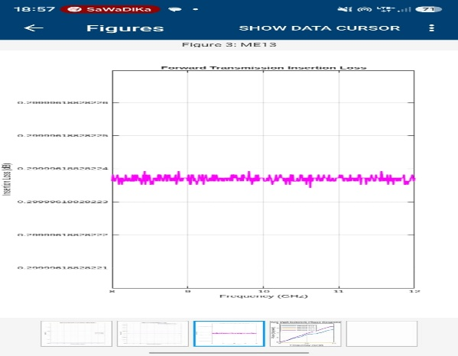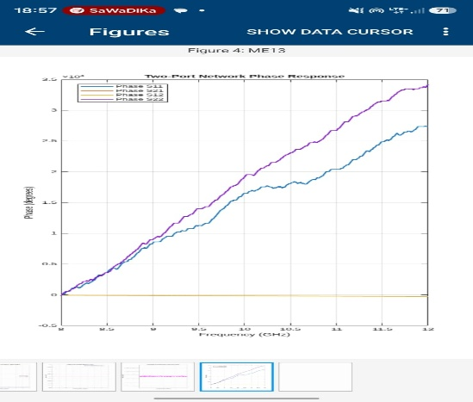
Result:
The microwave two-port network was simulated and characterized successfully using S-parameters. Frequency-dependent reflection and transmission characteristics were analyzed, and vector network analyzer emulation was performed to evaluate the network's overall microwave performance.

